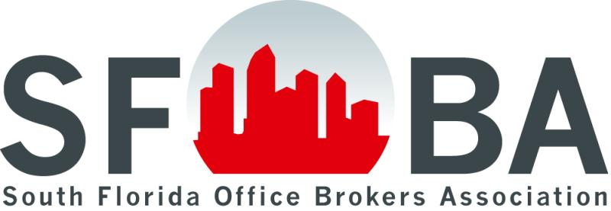

South Florida Office Brokers Association
2020 Meeting Schedule

Dates | To be hosted by:
January 16, 2020  Lunch | AVAILABLE
February 13, 2020  Lunch | Arium West  7771 W. Oakland Park Blvd., FTL 33351
March 12, 2020  Lunch | Broward County
April 16, 2020  Lunch | MM Portfolio in Sawgrass  Sunrise
May 14, 2020  Lunch | AVAILABLE
June 11, 2020  Lunch | AVAILABLE
July 9 or 16, 2020  Lunch | AVAILABLE
August 13, 2020  Lunch | AVAILABLE
September 10, 2020  Lunch | Lakeside Office Center  600 N. Pine Island Rd., Plantation 33324
October 15, 2020  Lunch | MPOC  Miramar
November 12, 2020  Lunch | Broward County
December 3, 2020  Lunch or  Holiday Happy Hour | Palm Beach County

